HITEC UNIVERSITY TAXILA
Department of Computer Science
BS Computer Science Program
4st Semester, Session-2023 Section C
Lab Mid-Term Examination, Spring 2025
Subject: | CS-302L Artificial Intelligence Lab | Date: | Friday, April 25, 2025
Marks: | 25 | Time: | 60 Minutes
Name: |  | Reg. No.:

GENERAL INSTRUCTIONS:
- Usage of Mobile phones is strictly prohibited.
- Communication of any kind is strictly prohibited.
- Transfer of data in any form is not permitted.
- Read each question carefully and follow the instructions.

Task #1 | Paper A  [CO-4 – P4] [SO – 5] | (Marks: 10)
Construct a program where:
- The user enters their favorite movie genres (e.g., action, comedy, drama) into a set.
- Movies are stored in a dictionary where the key = genre and the value = a list of movies.
- Use a function to recommend movies based on the user’s preferred genres.
- Use a loop to display suggestions.
- If no recommendations are available for a genre, display a message like: "No movies found in this genre."
- Create a class MovieUser and a subclass MovieEngine using inheritance to manage input and output.

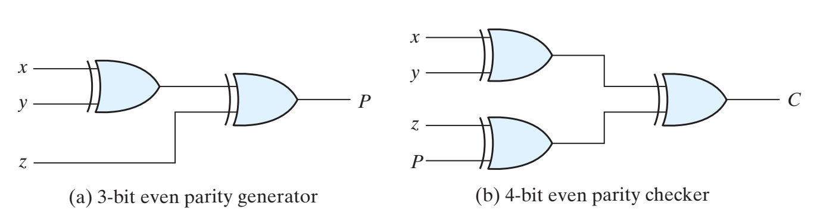
Task #2 | [CO-4 – P4] [SO – 5] | (Marks: 15)
Based on the dataset provided, attempt the following questions.
- How many male and female athletes are there?
- What is the maximum and minimum height recorded among athletes?
- How many athletes weight above 80 kg?
- Construct a box plot of Weight grouped by Gender.
- How many columns are present in the dataset?
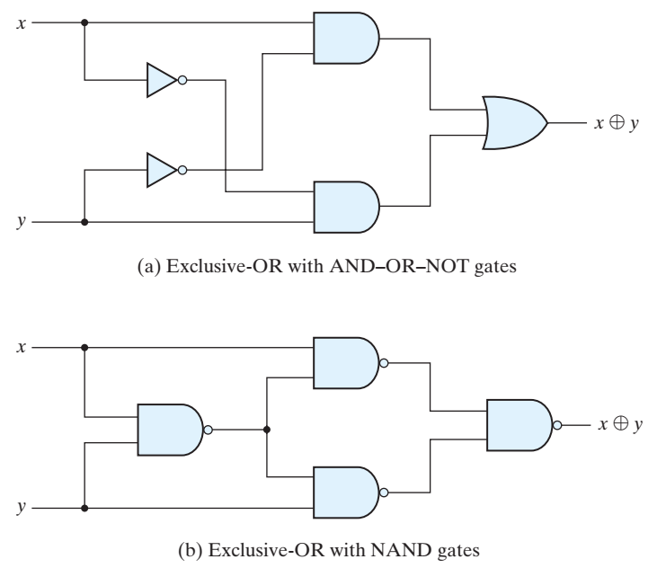

HITEC UNIVERSITY TAXILA
Department of Computer Science
BS Computer Science Program
4st Semester, Session-2023 Section C
Lab Mid-Term Examination, Spring 2025
Subject: | CS-302L Artificial Intelligence Lab | Date: | Friday, April 25, 2025
Marks: | 25 | Time: | 60 Minutes
Name: |  | Reg. No.:

GENERAL INSTRUCTIONS:
- Usage of Mobile phones is strictly prohibited.
- Communication of any kind is strictly prohibited.
- Transfer of data in any form is not permitted.
- Read each question carefully and follow the instructions.

Task #1 | Paper B  [CO-4 – P4] [SO – 5] | (Marks: 10)
Construct a program that:
- Takes the user's skills (e.g., coding, writing, analytics) as input into a set.
- Stores job roles in a dictionary where key = skill and value = list of related careers.
- Recommends careers based on the user’s skills using a function.
- Uses a loop to display results.
- Show “No suitable careers found” if there’s no match.
- Use single inheritance with UserProfile as the base class and CareerAdvisor as the derived class.


Task #2 | [CO-4 – P4] [SO – 5] | (Marks: 15)
Based on the dataset provided, attempt the following questions.
- Print the last 15 rows of the data frame.
- Are there any entries with missing values in the Confirmed, Deaths, or Recovered columns?
- Rename the column Deaths to Death count.
- What is the total number of deaths reported in the dataset?
- Construct a histogram showing the distribution of confirmed case counts.

